Rustic Montana Outdoors
INVOICE/ORDER Form 2016
WHOLESALE
Pick-n-Choose
Minimum Order – 60 Postcards
DATE Ordered:
Sold/Ship to:

Vintage Outdoor Montana
Custom Postcards Designed for your business

 | 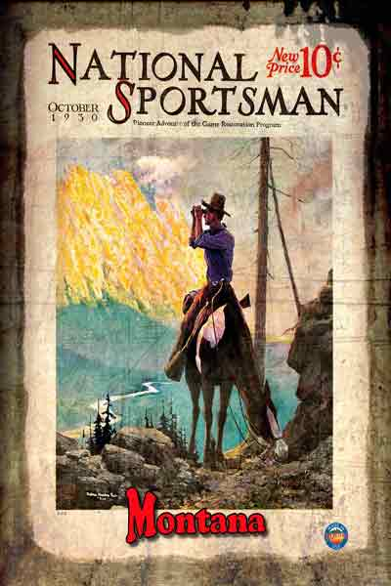 | 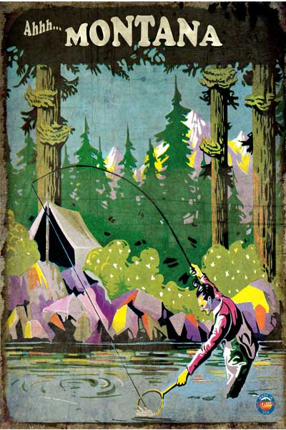 | 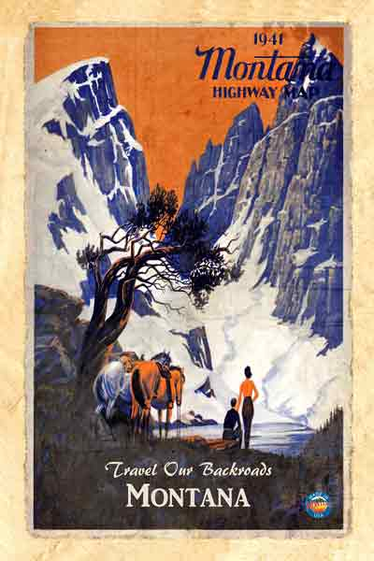 | 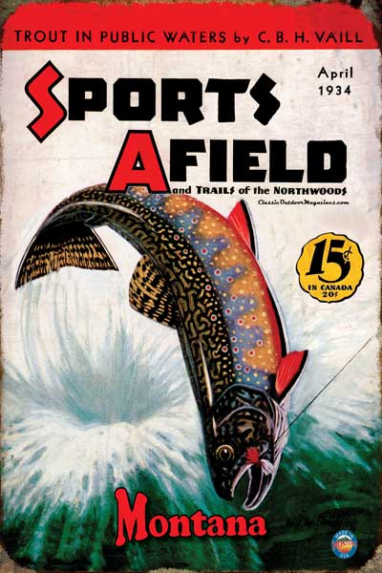 | 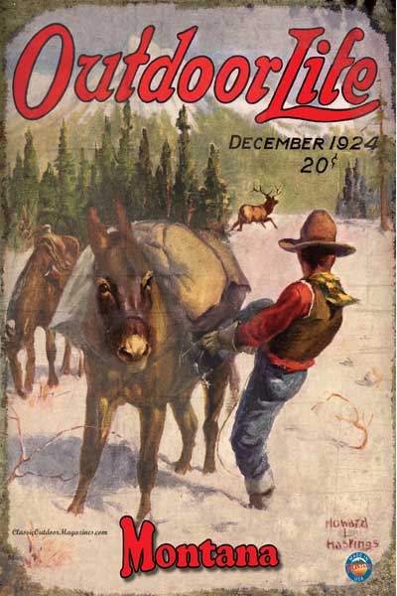 | 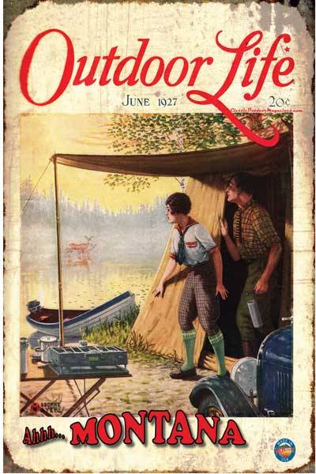
 | Mountain Hunter | Stream Angler | Montana Road Map | Jumping Trout | Elk Hunter | Campers
Number Ordered
 | 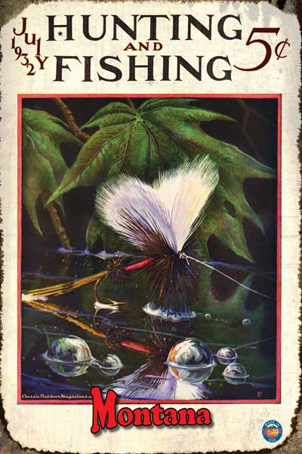 | 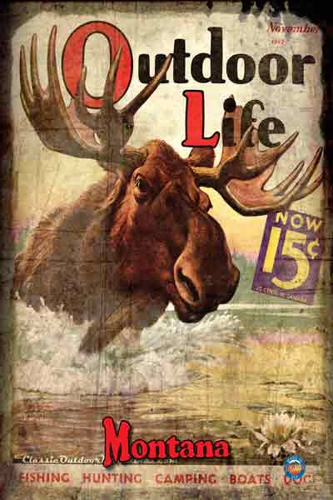 | 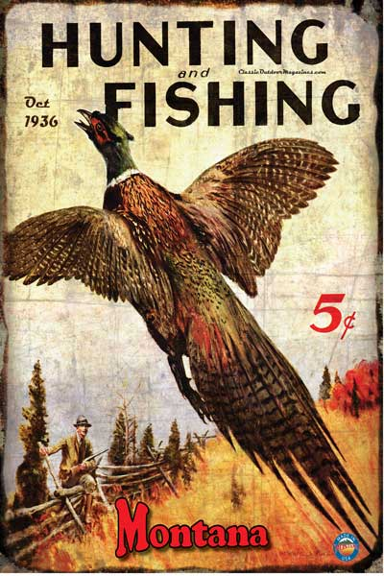 | 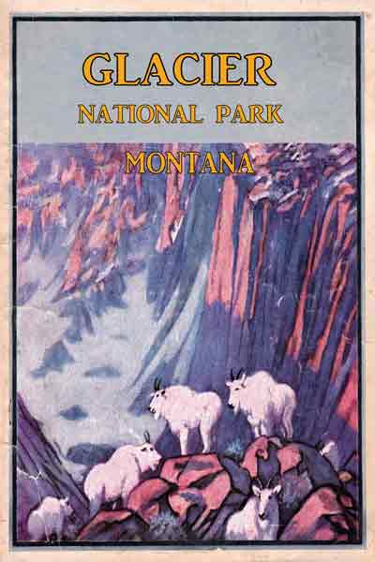 |  | 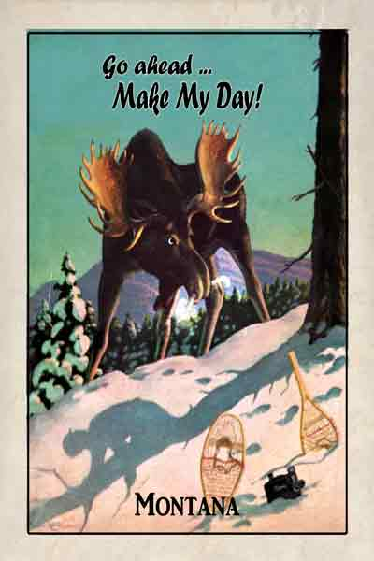
 | The Fly | Outdoor Life Moose | Pheasant | Glacier NP | Fly Montana Sky Personalized for your location | Make My Day Moose
Number Ordered
 | Minimum Order - 60 … Pick any Design in increments of 10 … $52.00
 | Double Order – 120 … Pick any Design in increments of 10 … $84.00
 | Add your business graphic/logo to custom back – No Charge

FREE SHIPPING
Number of Postcards
TOTAL POSTCARD ORDER

Please call or email questions. 406-552-2569
Email/mail form to: Bob@ClassicOutdoorMagazines.com
Bob Pitman
5732 Fox Trail
Florence, Montana 59833

Send check to

Easy web-based ordering, invoicing & product information. Business “Net 30” applies

